­­­­­­­­Social Studies Holiday Homework 2021

Subject Teacher: Submitted by:

Ms. Tulika Narbar Ansh Kumar,

Class: VI – D

Admiss. No. 2675

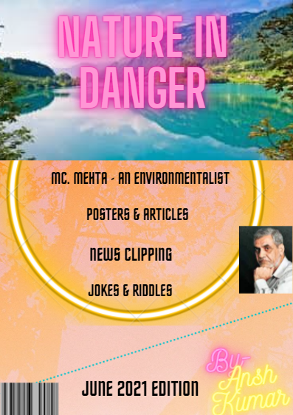

Table of Contents

Editorial

Born on 4th November 2010 in New Delhi, Ansh Kumar has eternal love towards nature and its belongings. He always has keen interest in saving environment and finding ways to preserve it. He has planted many plants in his garden as well as in parks to fulfill his duties towards nature. However, he has been perturbed with the global warming and how this new global pandemic has changed the world at large in just few months. COVID 19 has not only locked the entire world in cage but it has also changed the environment and lifestyle of people. Though lockdown has improved the quality of air but it has made us realize the importance of plants and hygiene. With the scarcity of oxygen amid COVID 19, it is still not late to realize the duty of every human being which they owe towards nature. Ansh Kumar takes it as an opportunity to show care towards mother nature and make people aware their utmost duty through this magazine.

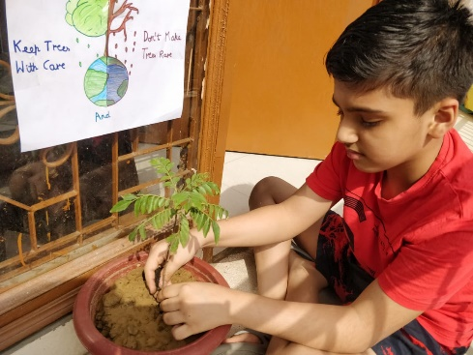The inspiration of this magazine comes from one of the renowned environmentalist Mr. M.C. Mehta. He used Public Interest Litigation platform as tool to save the environment. The magazine offers a complete platter comprising of inspirational story of Mr. M.C. Mehta, articles about environment and news clippings on environment and jokes and puzzles to keep readers glue to it and instill a responsibility in its reader to take care of the mother nature amid COVID 19.

__________________________________

Padma Shri MC Mehta

– An Environmentalist

­­­ A lawyer by profession and a committed environmentalist by choice, he has made the fight to protect India’s environment his unending mission. He has pioneered legal activism for environmental protection and is proof that one man can make a difference.

Born on October 12, 1946 M C Mehta (Mahesh Chander Mehta) belongs to a small village in district Rajouri in the State of Jammu & Kashmir (India). It was here that his love for nature, instilled in him a sense of commitment towards protecting the environment. He got his education up to primary level in his village Dhangri. His career as a Supreme Court lawyer began in 1983, when he migrated to Delhi. In 1984, he began focusing on environmental litigation. M.C. Mehta alone won numerous landmark judgments in India’s Supreme Court since 1984, including introducing lead-free gasoline to India and reducing the industrial pollution fouling the Ganga and eroding the Taj Mahal.

In early 1984, M.C. Mehta, a public interest attorney, visited the Taj Mahal for the first time. He saw that the famed monument’s marble had turned yellow and was pitted as a result of pollutants from nearby industries. This spurred Mehta to file his first environmental case in the Supreme Court of India.

The following year, M.C Mehta learned that the Ganga River, considered to be the holiest river in India and used by millions of people every day for bathing and drinking water, caught fire due to industrial effluents in the river. Once again, Mehta filed a petition in the Supreme Court against the polluting factories, and the scope of the case was broadened to include all the industries and municipalities in the river basin.

During the years that followed, a courtroom was set aside every Friday just for Mehta’s cases. In 1993, after a decade of court battles and threats from factory owners, the Supreme Court ordered 212 small factories surrounding the Taj Mahal to close because they had not installed pollution control devices. Another 300 factories were put on notice to do the same. The Ganga cases continued to be heard every week, and 5,000 factories along the river were directed to install pollution control devices and 300 factories were closed. Approximately 250 towns and cities in the Ganga in have been ordered to set up sewage treatment plants.

Mehta has won additional precedent-setting suits against industries that generate hazardous waste and succeeded in obtaining a court order to make lead-free gasoline available. He has also been working to ban intensive shrimp farming and other damaging activities along India’s 7,000 km shore.

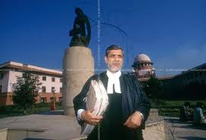Mehta has succeeded in getting new environmental policies initiated and has brought environmental protection into India’s constitutional framework. He has almost alone obtained about 40 landmark judgments and numerous orders from the Supreme Court against polluters, a record that may be unrivaled by any other environmental lawyer in the world.

Mehta is currently working with the [M.C. Mehta Environmental Foundation](https://mcmef.org/), an NGO that provides training programs for aspiring environmental attorneys and runs numerous environmental justice campaigns.

In the words of Ms. Smita Gate “Often described as the One Man Enviro-legal Brigade, Mr. Mehta is probably the only Supreme Court lawyer to have taken up legal cudgels with the polluting Indian Industries and come out victorious. A dedicated, fearless and extremely honest man, he pursues his goals with single-minded devotion. He has been conferred with several prestigious awards. Some of these are the Governor’s Gold Medal, the Goldman Environmental Prize, considered on alternative Noble Prize in USA and Europe, the UN’s Global 500 Award for 1993 and above all the Magsaysay Award for 1997.”

__________________________________

News clippings

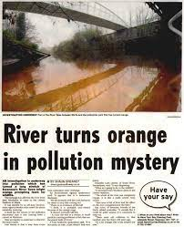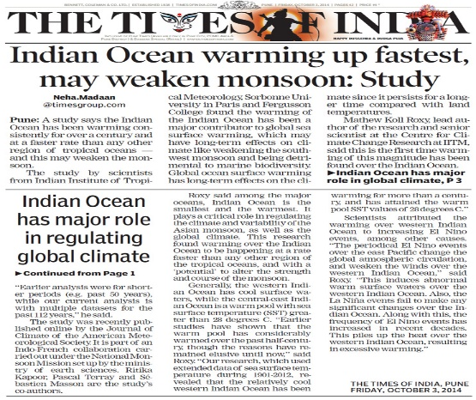

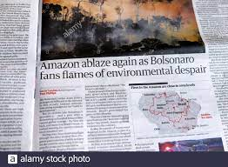

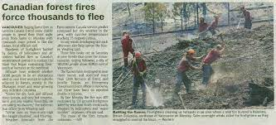

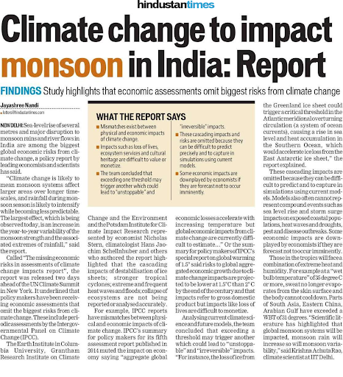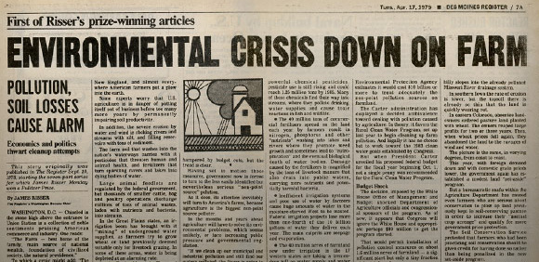

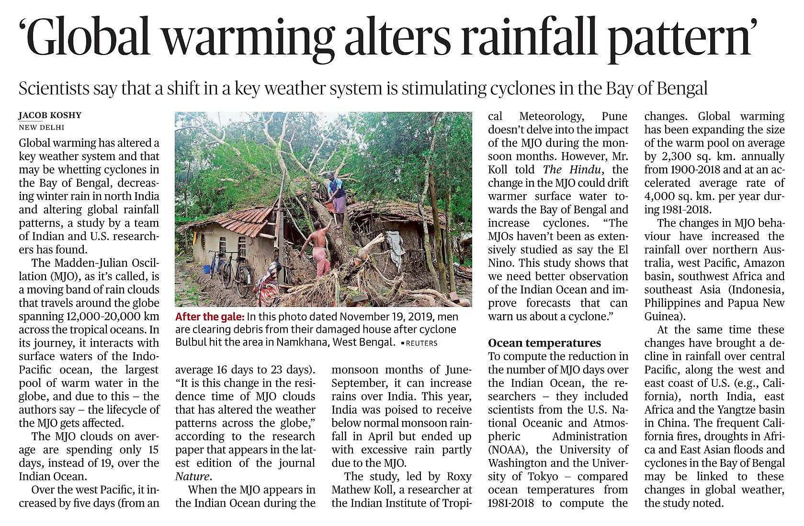

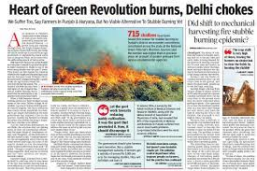

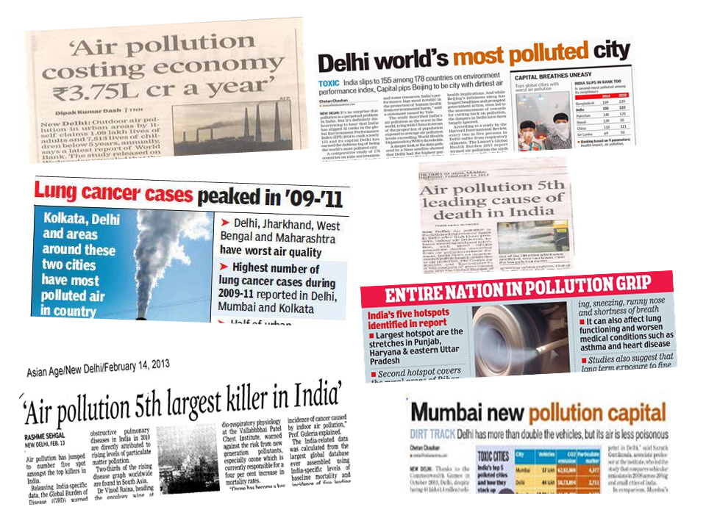

__________________________________

Article

(From the desk of Editor)

Everything you want to know about Air Pollution

*-by Ansh Kumar[1]*

1. 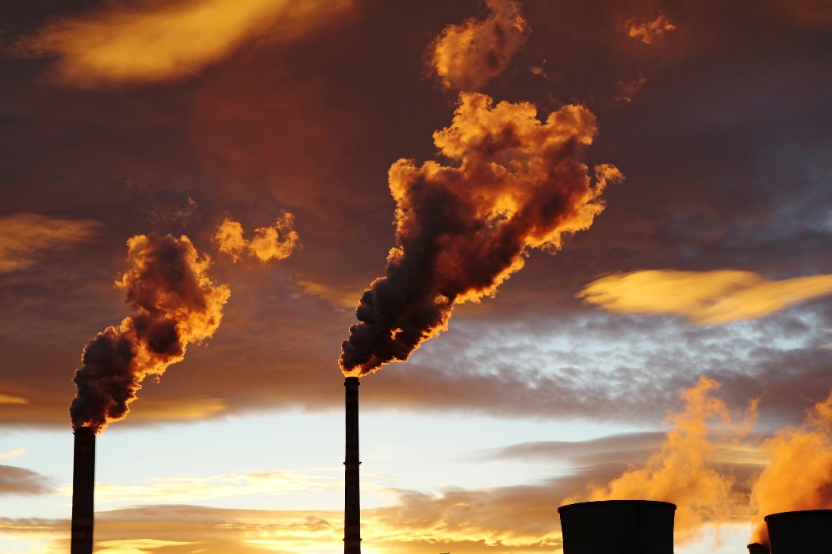**Introduction:**

Air pollution refers to any physical, chemical or biological change in the air. It is the contamination of air by harmful gases, dust and smoke which affects plants, animals and humans drastically. Air pollution, a global concern has been rising these years. There are many people who don’t know how harmful air pollution is to the environment and specially to humans.

1. **Causes:**

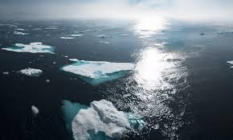Air pollution is caused by solid and liquid particles and certain gases that are suspended in the air. Burning of fossil fuels, vehicles, factories, stubble burning, industrial emissions, wildfires, open burning of garbage wastes, construction & demolition, use of chemicals and agricultural actives have contributed in making air polluted.

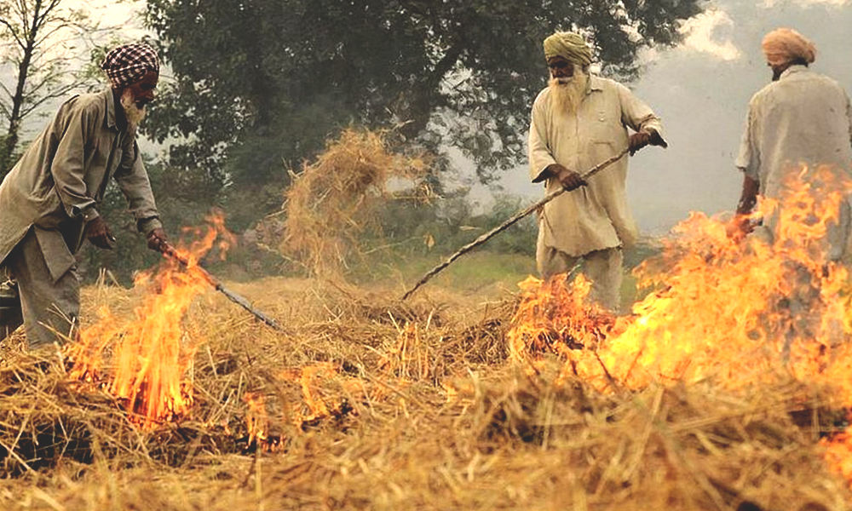Most of the air pollution takes place due to the burning of fossil fuels such as coal, oil, gasoline to produce energy for electricity or transportation. The release of carbon monoxide in high level indicates how much fossil fuel is burned. This also emits other toxic pollutants in the air. Industrial activities emit several pollutants in the air that affects the air quality. Particulate matter 2.5 and 10, Nitrogen dioxide, Sulfur dioxide, and carbon monoxide are [key pollutants that are emitted](https://www.aqi.in/blog/how-monitoring-air-quality-data-has-become-an-absolute-necessity/) from industries that use coal and wood as their primary energy source for production of their goods. Use of toxic products, inadequate ventilation, uneven temperature, and humidity level [can cause indoor air pollution](https://www.aqi.in/blog/how-your-in-house-air-quality-is-worse-than-the-outdoor-one/), whether you are in office, school or at your comfortable home. House air pollution can take place due to ignorant factors, for instance, [smoking tobacco inside a room](https://www.aqi.in/blog/cigarettes-smoke-air-pollution/) or leaving mold infected wall untreated. Climate change is not just increasing wildfire but also spiking air pollution. Manufacturing, chemical, and textiles industries release a large number of carbon monoxides, hydrocarbons, chemicals and organic compounds which contaminate our environment. Bacteria and fungi play a fundamental role in the biogeochemical cycles in nature. They are the key indicators of abnormal environmental conditions. Decaying of these microorganisms present in the surrounding releases 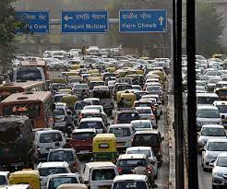methane gas which is highly toxic**.** There is no denying that vehicle pollution is the major contributor to air pollution, especially in urban cities. When the car burns gasoline, it emits pollutants in the air which is as harmful as smoking 10 cigarettes a day. Your vehicle emits carbon monoxide, hydrocarbons, nitrogen oxide, and particulate matter. Open burning of garbage is much more harmful to your health and the environment than one may think. With the rise of population in the city, construction and demolition is a part of the ever-going development phase of the national capital. Agricultural activities have had a serious impact on the decreasing air quality. To begin with, pesticides and fertilizers are the main source to contaminate the surrounding air. Nowadays, pesticides and fertilizers are mixed with new invasive species which are not found in nature, for quick growth of the crops and vegetation. Once they are sprayed over, the smell and the effect of the pesticides are left in the air.

In recent years Northern India is facing a new challenge posed by stubble burning. [Burning stubble and farm residue](https://www.aqi.in/blog/stubble-burning-and-its-impact-on-the-environment/)is also a major contribution to wildfire. It causes increased PM 2.5 in the air which collides with other harmful substances like chemical gas and pollen creating smog. Plumes of smoke from farmers' paddy fields envelop the area of nearby states. Stubble burning is a big cause of air pollution specially at the onset of winters. Stubble burning has created a massive public health crisis - its fumes pollute swathes of northern India and endanger the health of hundreds of millions of people. And it's more dangerous amid Covid-19 ravaging the country as pollution makes people more vulnerable to infection and slows their recovery.

1. **Effects:**

There are varied effects of air pollution on this planet. Effects of air pollution can be felt on human being as well as on environment.

**III.A On public health:**

People experience a wide range of health effects from being exposed to air pollution. Air Pollution is choking public health. Inhaling air induced with pollutants due to the burning of natural gas and fossil fuel reduces heart’s ability to pump enough oxygen causing one to suffer respiratory illness. Industrial pollution effects associated with your health can range from irritation in your eyes and throat to breathing issues, at times can even lead to chronic illness. Use of wood stove or space heaters is capable to increase the humidity level which can directly affect the health a person in no time. Smog makes the air hazy and people find it difficult to breathe. Decaying of these microorganisms present in the surrounding releases methane gas which is highly toxic**.**Breathing toxic gas like methane may lead to death. When the vehicle pollution is high in the atmosphere, it creates a hole in the ozone layer contributing to smog and causing various health issues. Exposure to open burning of garbage waste can pose serious health risk including cancer, liver issues, impairment of immune system, reproductive functions; can also affect the developing nervous system. Several construction sites and raw materials such as bricks and concrete cause haze and foul air which is hazardous for the people especially, children and elderly citizens. Once they are sprayed over, the smell and the effect of the pesticides are left in the air. Some mix with water and some seeps into the ground which not only destroys the crops but also causes numerous health-related issues.

**III.B On environment:**

Air pollution has serious effects not only on public health but it also causes serious repercussions on environment. Like people, animals, and plants, entire ecosystems can suffer effects from air pollution, such as-

* Global Warming
* Climate Change
* Acid Rain
* Smog effect
* Deterioration of fields

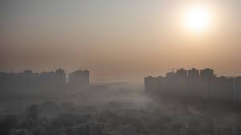Global warming occurs when carbon dioxide (CO2) and other air pollutants collect in the atmosphere and absorb sunlight and solar radiation that have bounced off the earth’s surface. Normally this radiation would escape into space, but these pollutants, which can last for years to centuries in the atmosphere, trap the heat and cause the planet to get hotter. These heat-trapping pollutants—specifically carbon dioxide, methane, nitrous oxide,

water vapor, and synthetic fluorinated gases—are known as greenhouse gases, and their impact is called the greenhouse effect.

Air pollution and climate change are closely related. As well as driving climate change, the main cause of CO2 emissions – the extraction and burning of fossil fuels – is also a major source of air pollutants. What’s more, Many air pollutants contribute to climate change by affecting the amount of incoming sunlight that is reflected or absorbed by the atmosphere, with some pollutants warming and others cooling the Earth. These short-lived climate-forcing pollutants (SLCPs) include methane, black carbon, ground-level ozone, and sulfate aerosols. They have significant impacts on the climate: black carbon and methane in particular are among the top contributors to global warming after CO2.

Air pollution can damage crops and trees in a variety of ways. Ground-level ozone can lead to reductions in agricultural crop and commercial forest yields, reduced growth and survivability of tree seedlings, and increased plant susceptibility to disease, pests and other environmental stresses (such as harsh weather).

The burning of fossil fuels releases harmful gases such as nitrogen oxides and Sulphur oxides in the air. The water droplets combine with these pollutants, become acidic and fall as acid rain which damages human, animal and plant life.

Toxic pollutants in the air, or deposited on soils or surface waters, can impact wildlife in a number of ways. Like humans, animals can experience health problems if they are exposed to sufficient concentrations of air toxics over time. Air pollutants also deteriorate and change the constitution of building materials, so many buildings and infrastructure are weakened, eroded or destroyed at an accelerated rate over time. Deterioration of Taj Mahal because of air pollution is one of the prime example.

1. **Conclusion & Suggestions:**

As we saw that the Air pollution is so dangerous so it becomes important to know how to prevent it. So, here are some prevention and measures to be taken to prevent Air Pollution.

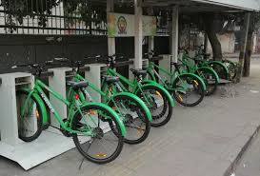Avoid Using Vehicles

People should avoid using vehicles for shorter distances. Rather, they should prefer public modes of transport to travel from one place to another. This not only prevents pollution, but also conserves energy.

Energy Conservation

A large number of fossil fuels are burnt to generate electricity. Therefore, do not forget to switch off the electrical appliances when not in use. Thus, you can save the environment at the individual level. Use of energy-efficient devices such CFLs also controls pollution to a greater level.

Use of Clean Energy Resources

The use of solar, wind and geothermal energies reduce air pollution at a larger level. Various countries, including India, have implemented the use of these resources as a step towards a cleaner environment.

Other air pollution control measures include:

1. By minimizing and reducing the use of fire and fire products.
2. Since industrial emissions are one of the major causes of air pollution, the pollutants can be controlled or treated at the source itself to reduce its effects. For example, if the reactions of a certain raw material yield a pollutant, then the raw materials can be substituted with other less polluting materials.
3. Fuel substitution is another way of controlling air pollution. In many parts of India, petrol and diesel are being replaced by CNG – Compressed Natural Gas fueled vehicles. These are mostly adopted by vehicles that aren’t fully operating with ideal emission engines.
4. 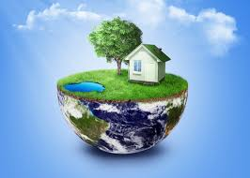Although there are many practices in India, which focus on repairing the quality of air, most of them are either forgotten or not being enforced properly. There are still a lot of vehicles on roads which haven’t been tested for vehicle emissions.
5. 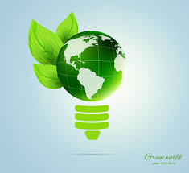Another way of controlling air pollution caused by industries is to modify and maintain existing pieces of equipment so that the emission of pollutants is minimized.
6. Sometimes controlling pollutants at the source is not possible. In that case, we can have process control equipment to control the pollution.
7. A very effective way of controlling air pollution is by diluting the air pollutants.
8. The last and the best way of reducing the ill effects of air pollution is tree plantation. Plants and trees reduce a large number of pollutants in the air. Ideally, planting trees in areas of high pollution levels will be extremely effective.

**Thank**

**You**

__________________________________

Guest Space

Poster - by Dr. Shweta Shree

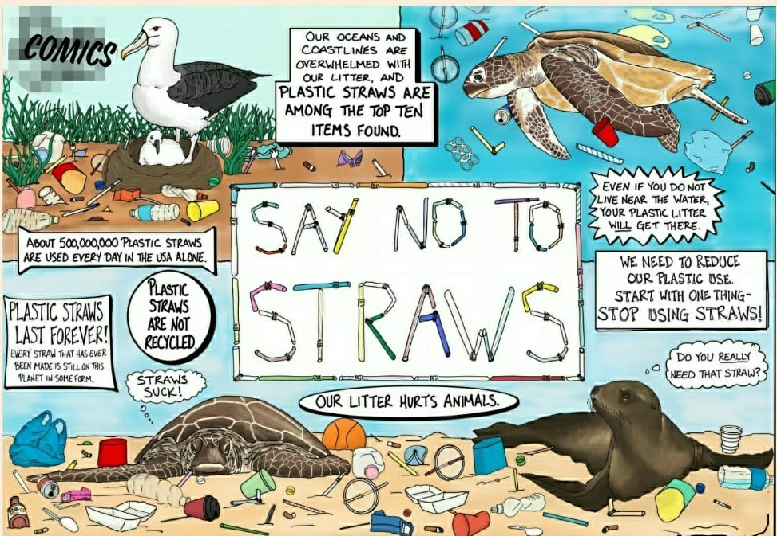

Jokes and Riddles

1. A small ATM room having two ACs and 4 tube lights, working 24 hours, is asking me not to print a receipt to save the environment. 
2. We all have to do our part for the environment. And there are many different ways one can save energy. I normally use the couch.
3. Why does a Time Magazine survey state only 85% of Americans think global warming is happening? A: The other 15 percent work for the oil industry!
4. Why do all eco-friendly consumers love T&A? A: Because they think it stands for Trees and [Air Quality](https://www.conserve-energy-future.com/what-is-air-quality.php)!



1. You name one thing that has done more for the environment than Greta Thunberg! A: The Coronavirus
2. What kind of plant grow on your hand? A:Palm tree
3. Why did the leaf go to the doctor? A: It was feeling green.
4. How can you tell the ocean is friendly? A: It waves.
5. If Mac users care more about the environment more than Windows users*.* Then why do Macs have a trash can and Windows has a [recycling bin](https://www.conserve-energy-future.com/recycle_bins.php)?



1. Most people claim they support recycling,but they sure get mad when someone reposts a joke.
2. What happens when Santa puts too much coal in your stocking at Christmas ? A: GLOBAL WARMING
3. If I ride my bike twice does that count as RE-CYCLING?
4. I am a shimmering field that reaches far. To the horizon I span beneath the universe's largest star. Yet I have no tracks and I am crossed without paths. What am I ? A: OCEAN

**

1. This is a type of extreme weather. That stretches from earth to sky. It is
2. strong enough to uproot trees. Its center is called an eye. A:TORNADO

__________________________________________________

**Thank You**

1. This article has been written after extensive research carried out by Ansh Kumar.